Background on Sentinel-2

SENTINEL-2 is a wide-swath, high-resolution, multi-spectral imaging mission supporting Copernicus Land Monitoring studies, including the monitoring of vegetation, soil and water cover, as well as observation of inland waterways and coastal areas. SENTINEL-2 was developed and operated by the European Space Agency, and has been sending data back to Earth since 23 June 2015.

The SENTINEL-2 data contain 13 spectral bands representing TOA reflectance scaled by 10000.

1. Used the geometry tools to make a point on NIT Patna campus (located in Patna ,Bihar ,india).

### Filtering image collections

### // This is our first line of code. Let’s define the image collection we are working with by writing this command

### var image = ee.Image(sent2

### // We will then include a filter to get only images in the date range we are interested in

### .filterDate("2015-07-01", "2019-09-30")

### // Next we include a geographic filter to narrow the search to images at the location of our point

### .filterBounds(campus)

### // Next we will also sort the collection by a metadata property, in our case cloud cover is a very useful one

### .sort("CLOUD\_COVERAGE\_ASSESSMENT")

### // Now lets select the first image out of this collection - i.e. the most cloud free image in the date range

### .first());

### // And let's print the image to the console.

### print("A Sentinel-2 scene:", image);

## **Adding images to the map view**

### Defining true-colour visualisation parameters

### C:\Users\vikra\AppData\Local\Packages\Microsoft.Office.Desktop_8wekyb3d8bbwe\AC\INetCache\Content.Word\TCC.PNG

### Defining false-colour visualisation parameters

### C:\Users\vikra\AppData\Local\Packages\Microsoft.Office.Desktop_8wekyb3d8bbwe\AC\INetCache\Content.Word\FCC.PNG

Deriving indices from band combinations

NDVI

NDVI = (NIR - RED)/(NIR + RED)

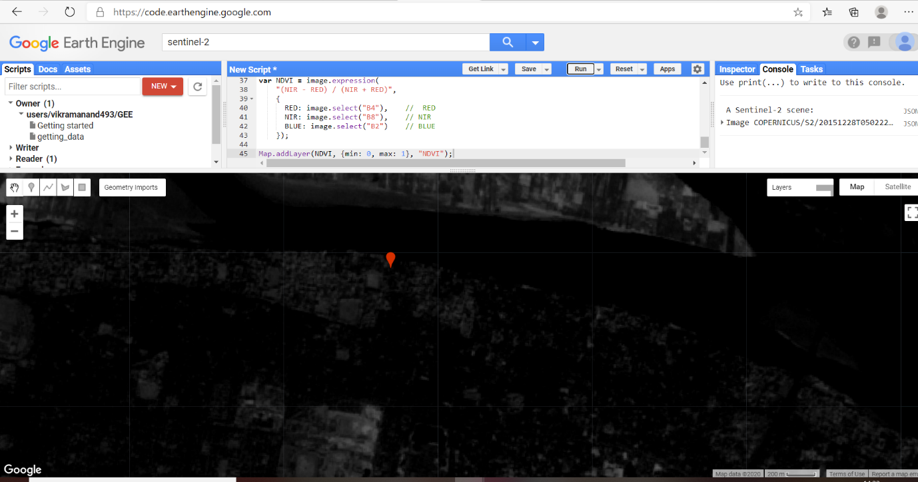

NDVI values range from 0 to 1, and the higher the value the more "vigorous" the vegetation. We can make a more interesting map of NDVI by defining a colour palette to use instead of black>white.